**Administrating VPC and EC2 services by launching Linux servers under Elastic load balancing rules under defined subnetworks with autoscaling method**

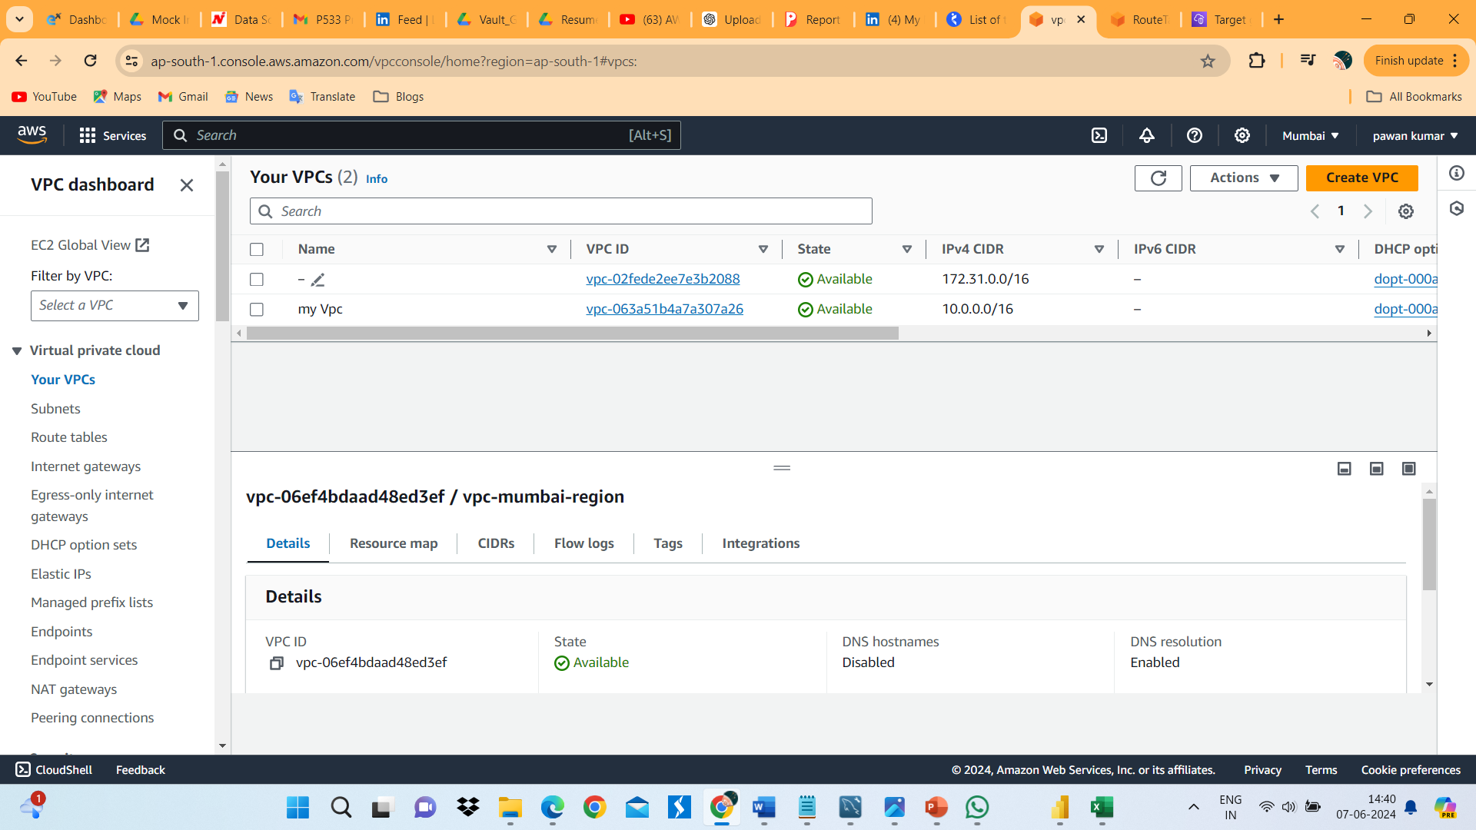

1. I have created VPC in Mumbai region with the name if my VPC.

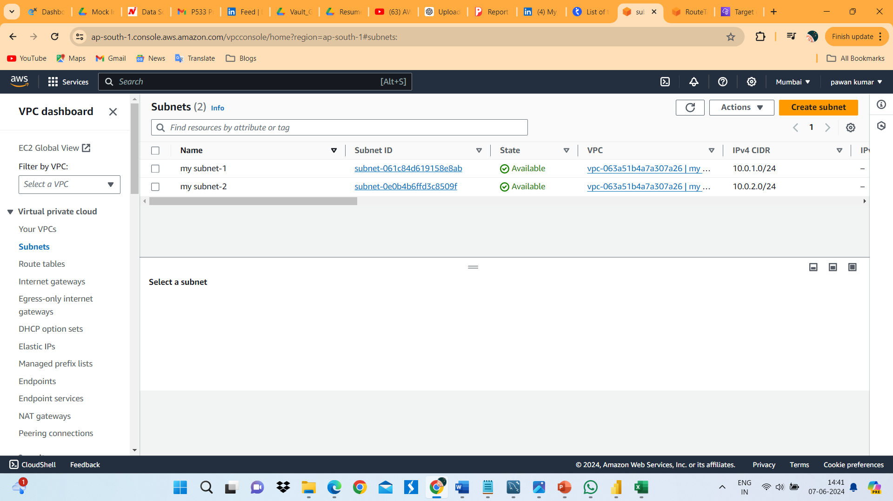

1. In my vpc I have created 2 public subnets.
2. We have created internet gateway for internet access to the vpn.

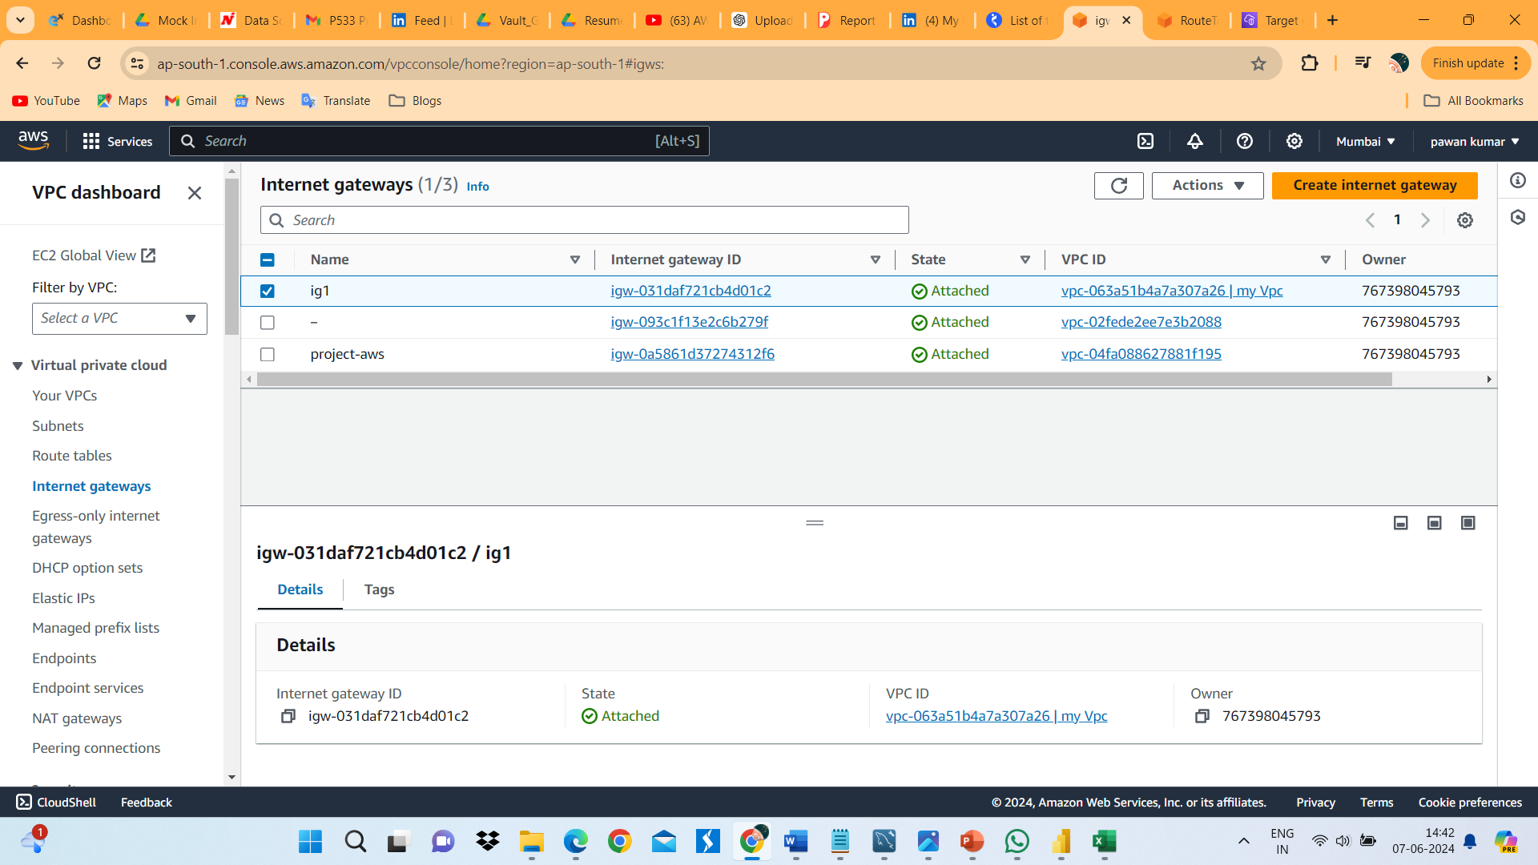

1. We have created route table. t is a route between subnents and internet gateway.

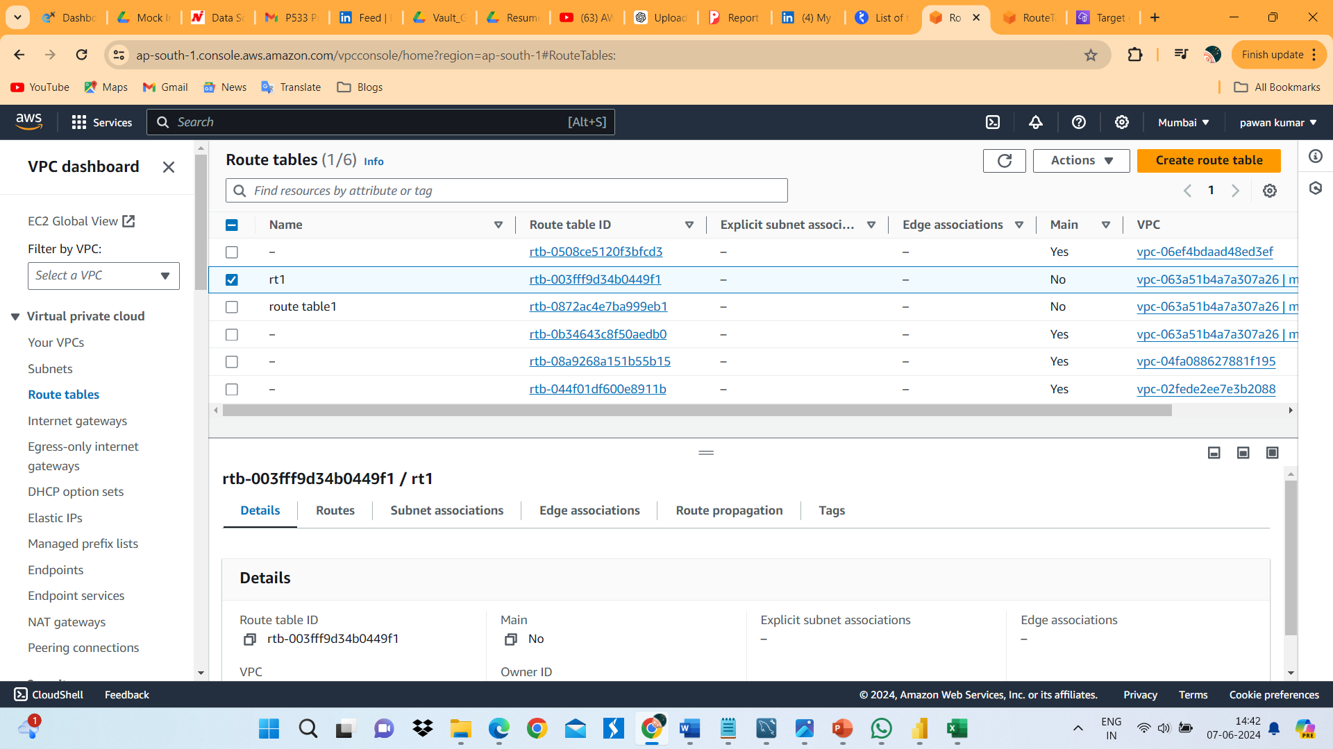

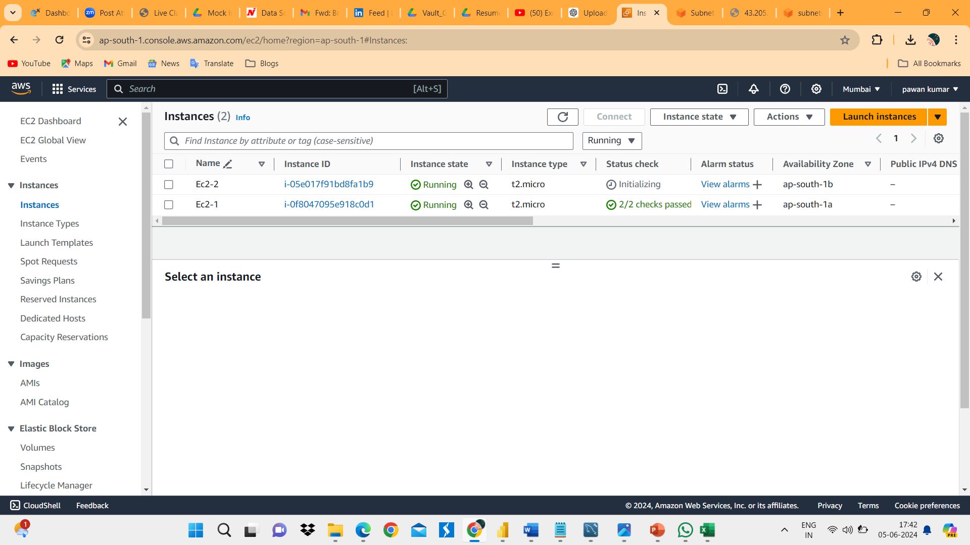

1. We have created 2 EC2 instance in 2 public subnets.
2. We have created target group for routing the request to target(EC2 Instance).

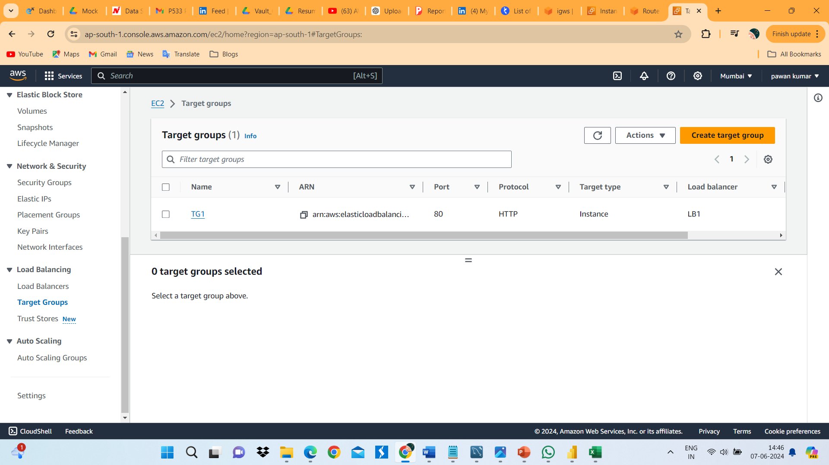

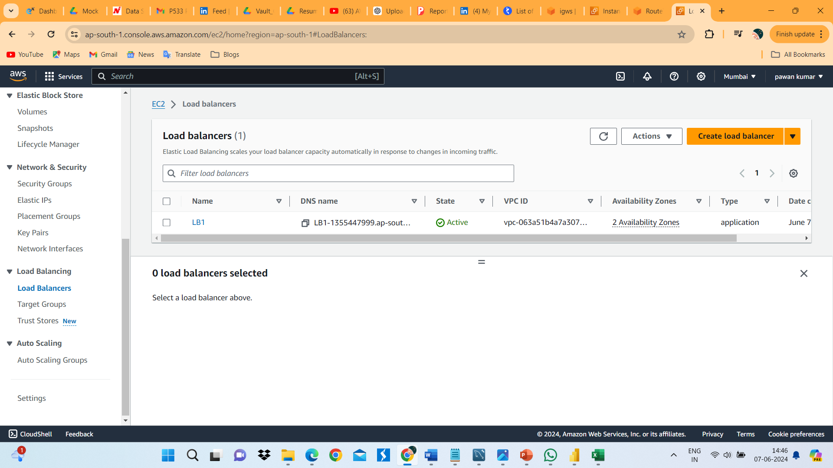

1. We created load balancer to distribute incoming traffic across multiple target.
2. We have created Launch template is a predefined set of configuration to ec2 instance.

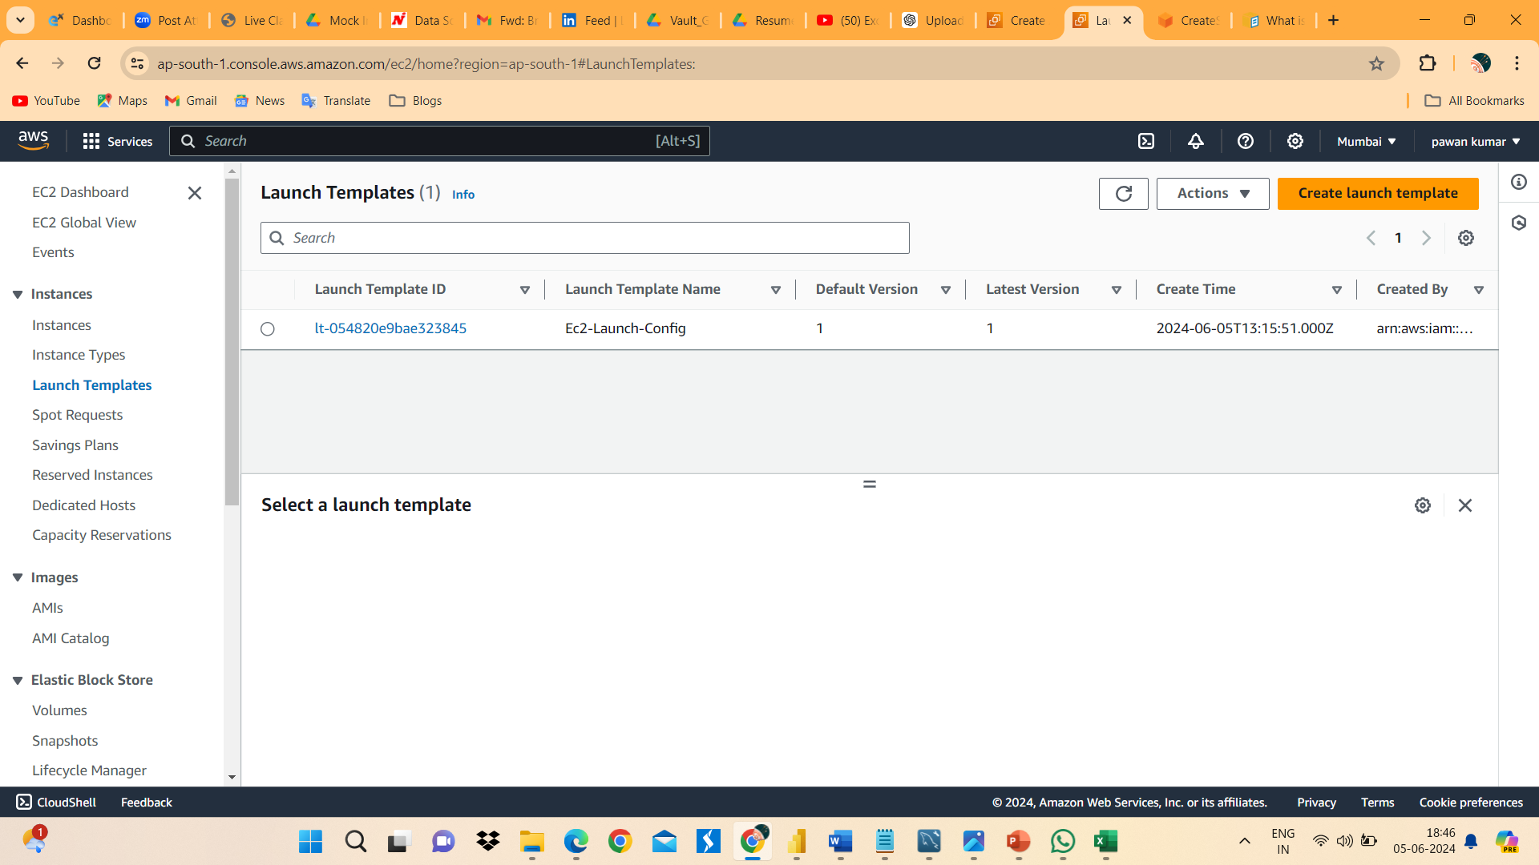

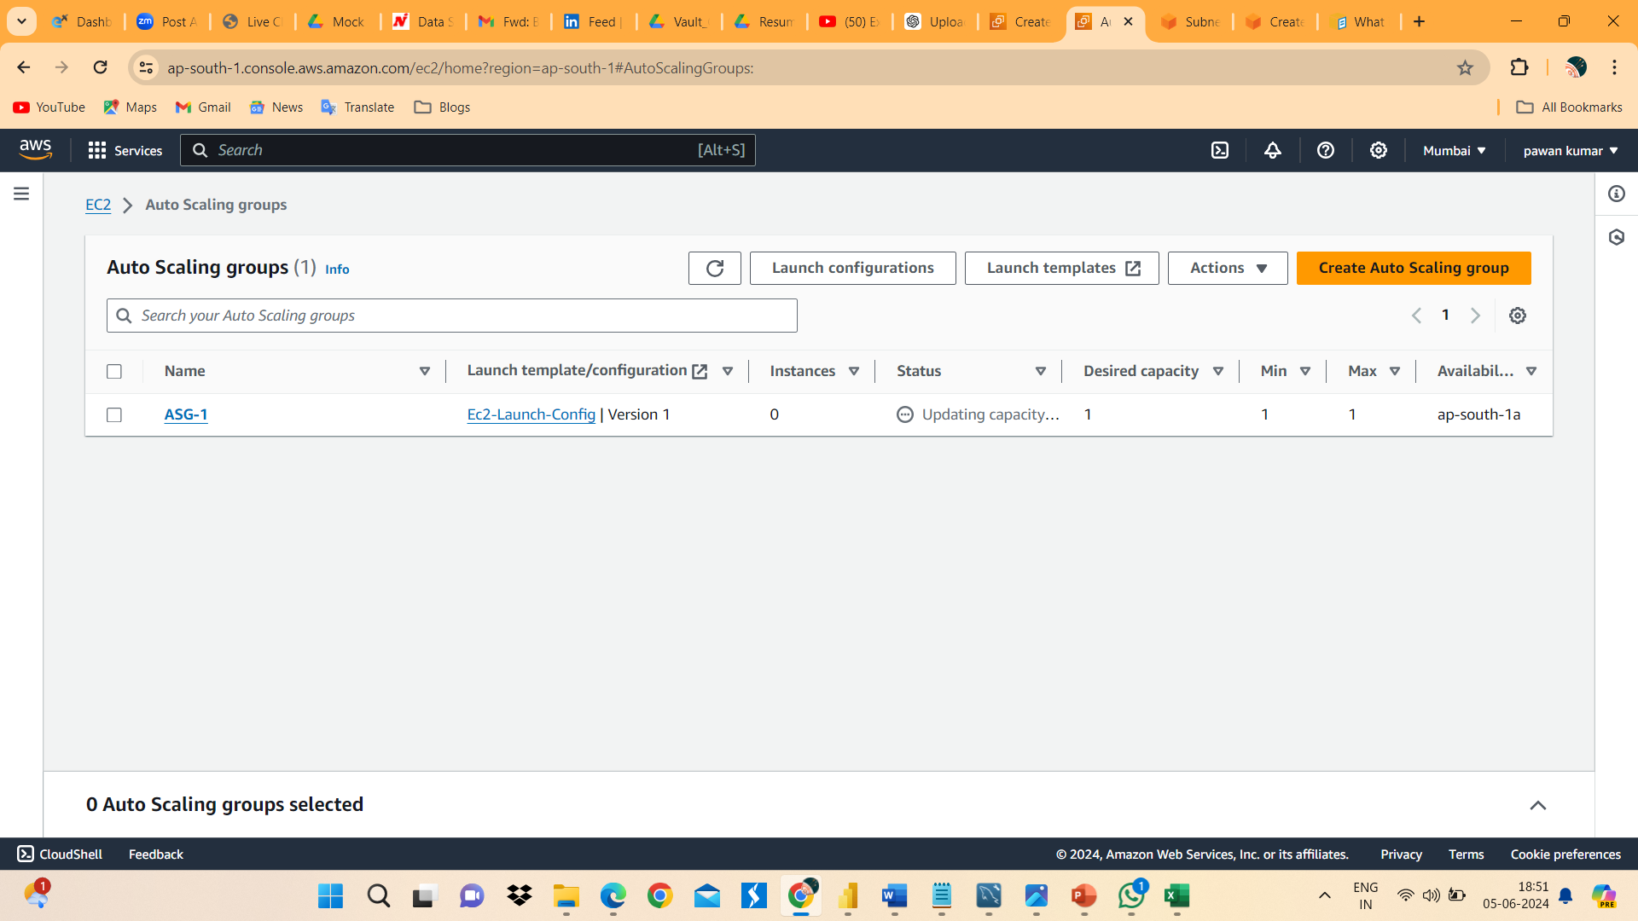

1. We have created auto scaing group for automatic scaling and management of EC2 Logical grouping.